|  |
| --- |
| **XLC Loader** |
|  |
| **User Guide** |
|  |
| Version: 1.00 |
| Created by: Asim |
| Updated by: |
| Last updated: 07-Jul-2017 |

|  |  |  |  |  |
| --- | --- | --- | --- | --- |
| **Version History Revision** | **Release Date** | **Updated By** | **Reviewed By** | **Comments** |
| 1.00 | 7-Jul-2017 | Asim Naeem | C.K. | Initial Creation |
| 1.00 | 12-Jul-2017 | Asim Naeem | C.K. | Step-by-step operations |
| 1.00 | 17-Jul-2017 | Asim Naeem |  | Latest screnshoots added |

Table of Contents

Introduction 3

Getting started 3

System Requirements 3

Assumptions 3

Environment 3

User 3

Installation 3

Application 3

Access Database Engine 6

Configuration 10

WD.XLC.WIN.exe.config 10

Log4net.log4net 11

Execution 12

Starting Application 12

Overview 12

Home 13

Mapping 18

Loader – Processing 22

# Introduction

XLC Loader is an application to process CSV files and dump the data into the database accordingly. Multiple instances can be invoked for this application which executes and process files in-parallel.

# Getting started

## System Requirements

* Operating System: Microsoft windows 7 (x86 or x64) and above
* Microsoft .Net Framework 4.5
* OledbDriver (Can find the OleDBDriver setup in XLC application folder after installation)
* IBM DB2 Client driver (Optional: if need to use DB2 database)
* Teradata client driver (Optional: if need to use Teradata database)
* Oracle client (Optional: if need to use oracle database)

## Assumptions

### Environment

It is assumed that

* All the required components are installed on the machine before continuing installation of XLC loader application.
* The required Database structure already exists on database server.
* The “inbox” folder already exist.

### User

It is assumed that the user:

* Have basic knowledge of Windows operating system and its basic functions.
* Administrative rights on target machine.
* Knows how to install application on the windows operating system
* Knows how to install and configure the database client.

## Installation

### Application

Please follow these steps to install the application on the machine.

* Download the setup file from FTP location.
  + <ftp://172.21.12.166/XLC/>
* Execute the setup file to start install shield for installation processes.

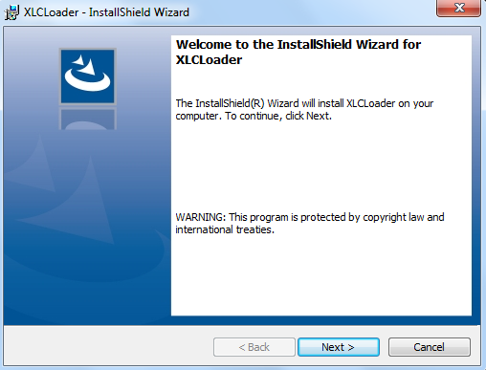

* Follow the instructions and install the application.
* Select the destination folder where application needs to be installed and click “next”

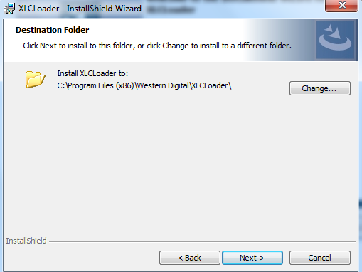

* Review the selected options summary and click “Install” to begin the installation.

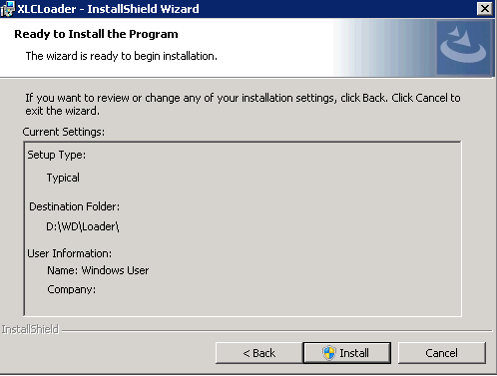

* Click yes if asked for administrative privileges.

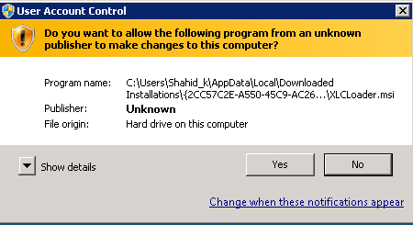

* After the installation is completed, click on finish to exit the install shield.

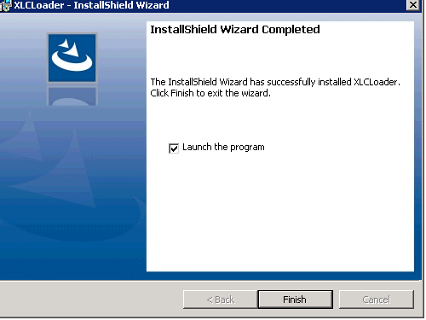

* The files in the installation folder will look like this.

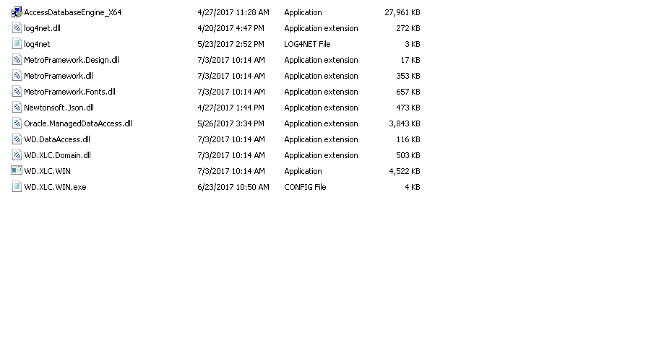

### Access Database Engine

To install the Access database Engine please follow these steps.

* Either go to application folder where the XLC application is installed

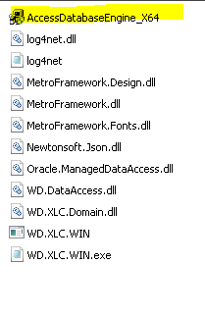

* OR go to **Start Menu > All Programs > Western Digital > XLC Loader** and then selec “Acess Database Engine”.

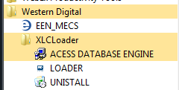

* Click Yes to begin the installation

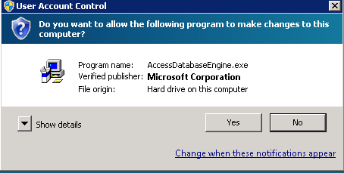

* Follow the step-by-step instructions of install shield in order to complete the process. Click “Next” to begin.

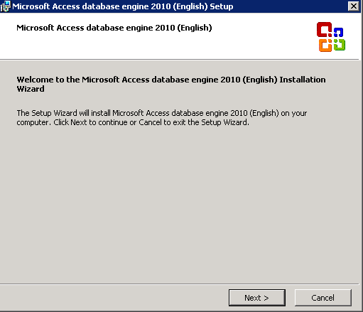

* Select the checkbox to accept license agreement and click “Next”.

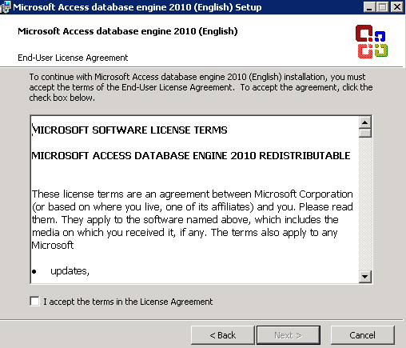

* Select the destination folder and click “Install”.

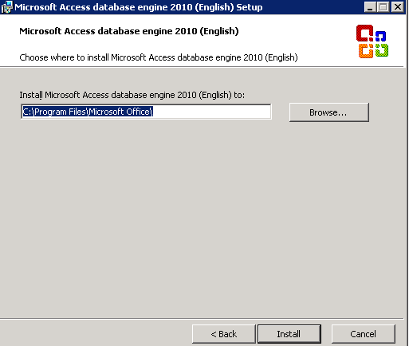

* Installation progress can be observed.

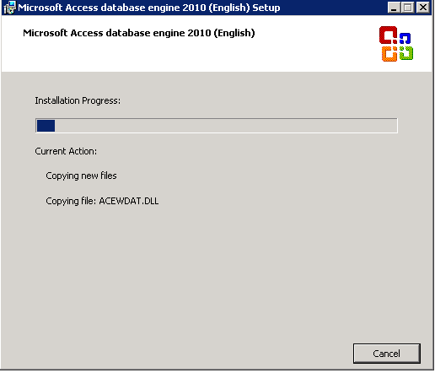

* After successful installation, click on “OK” to exit the installation process.

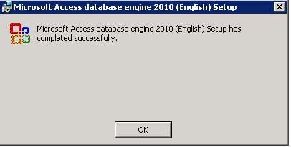

## Configuration

After Installation is finished, please find these configuration files in installation folder, and make the appropriate changes.

### WD.XLC.WIN.exe.config

* ConnectionStrings



* + Please create or modify the connection string setting and put the appropriate connection of database where XLC data needs to be inserted. By default the application will read the connection string with name “DefaultConnection”.
* AppSettings

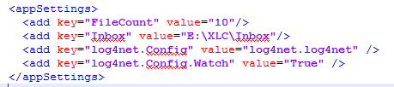

* + FileCount is the integer value which represents the maximum number of files processed by application simultaneously.
  + Inbox is the main repository of files to be processed. Set the value as absolute path of inbox folder. The application will move files from Inbox folder to its working folder for further processing.
  + Log4net.Config is the configuration file name for Log4Net.

### Log4net.log4net

* Specify the path of error log file and activity log file.
* User can select any of the folder on the machine.
* Make sure the folder must exist. However, the files can be created by application if not already exist.

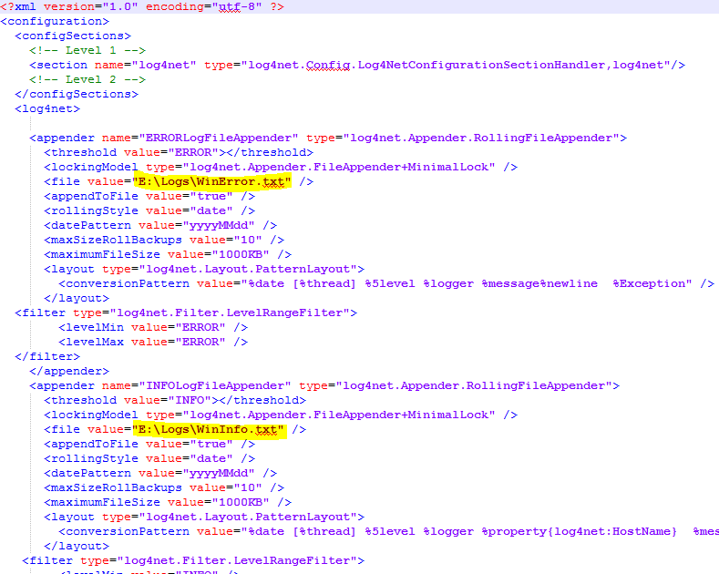

## Execution

### Starting Application

Application can be started from

* Either by double click the XLC loader icon on desktop



* Or by selecting “Loader” from **Start Menu > All Programs > Western Digital > XLC Loader**

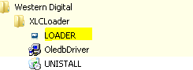

The XLC loader is multi instance application i.e. more than one instances of the application can be executed simultaneously. Each instance is numbered uniquely starting from 1.

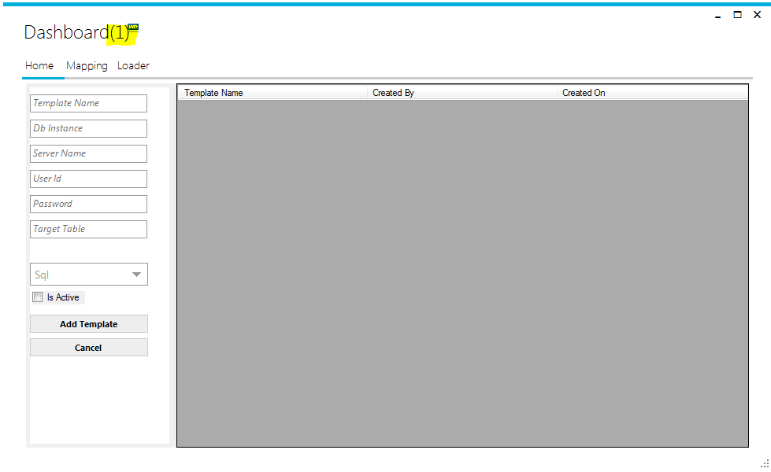

### Overview

There are 3 main Tabs of the application

* **Home:** This tab shows the list of templates already created on the system. It also have the template creation form on left hand side of application.
* **Mapping:** This tab provides a list of templates and details of mapping of selected template between columns of associated table of database and CSV file columns.
* **Loader:** Actual processing of raw CSV files can be performed here. One or more templates as well as the raw file repository (inbox folder) can be selected to start the data processing.

# Home

Templates are the mapping between raw data of CSV files and database structures. It provides information of each value, its target column in particular table, datatype and unique value constraint.

Please follow these steps to create a new template.

* Execute the application and choose the first tab “Home”.

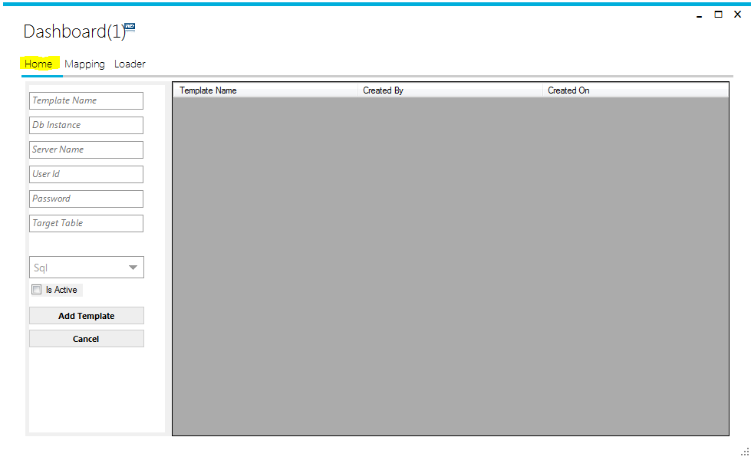

* On left hand side, there is an entry form to create new template.
* Enter a unique “Template Name” as Rec_Id in CSV files.

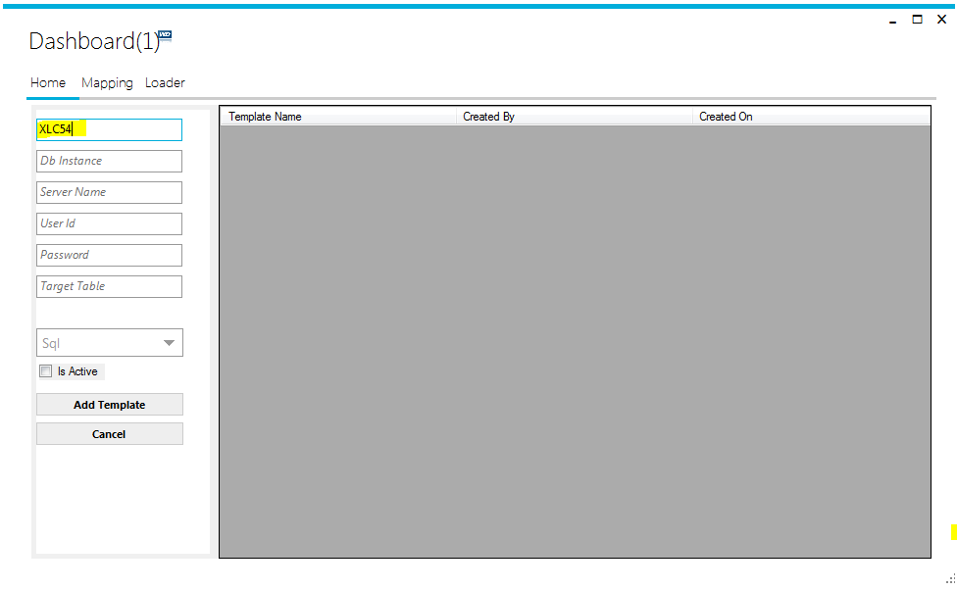

* Enter the target table name of database. Make sure the table exist in database.

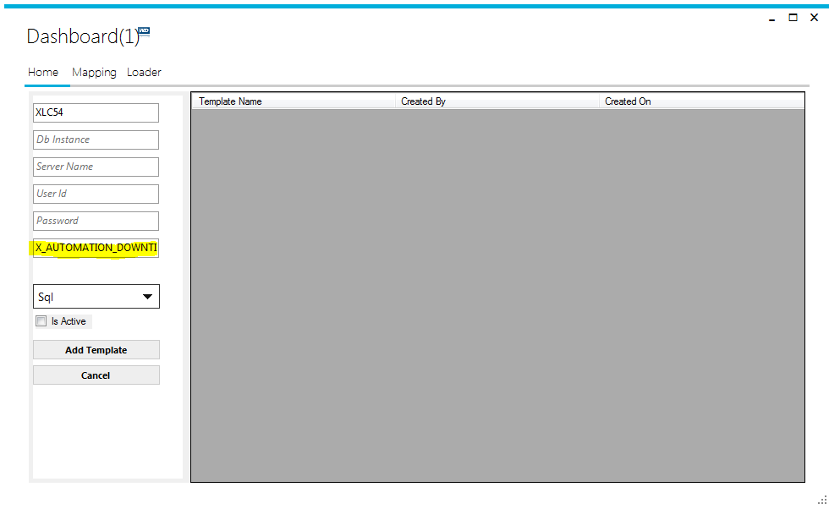

* Select the database server type (db provider) from drop-down list.

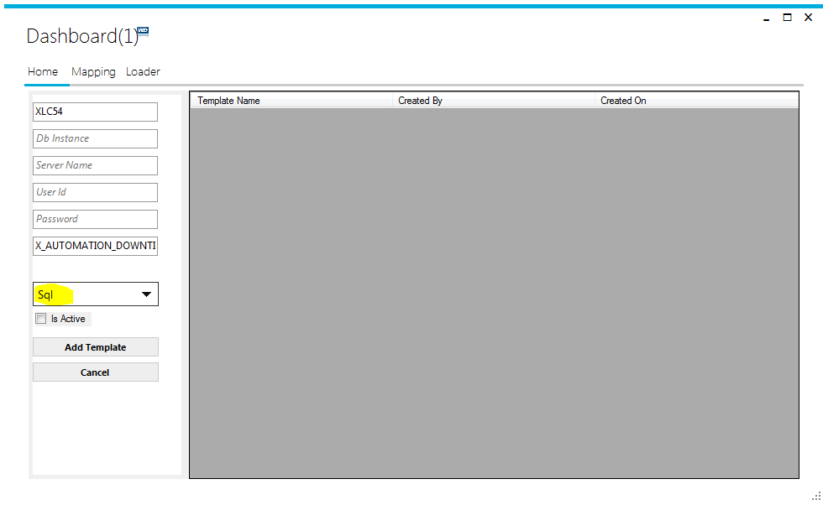

* Make sure the “Is Active” option must be checked.

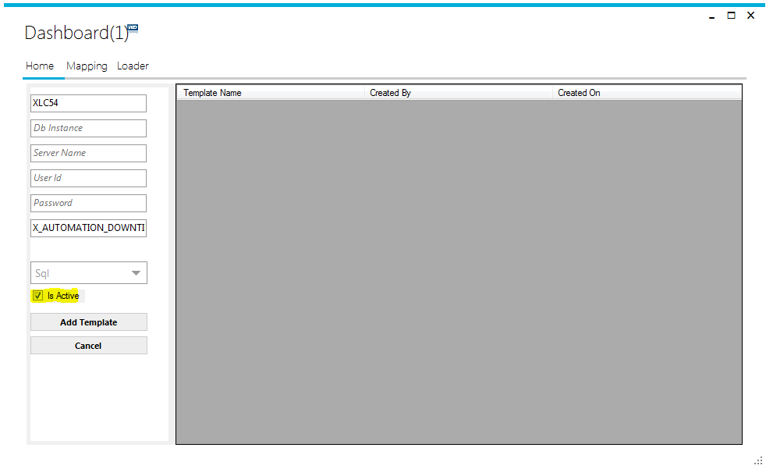

* Click on the “Add Template” button.

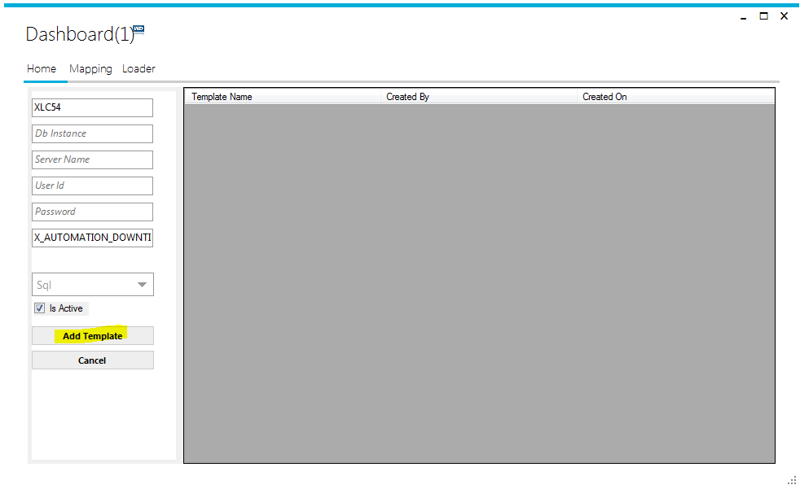

* On successful operation, the newly created template can be seen in the template list.

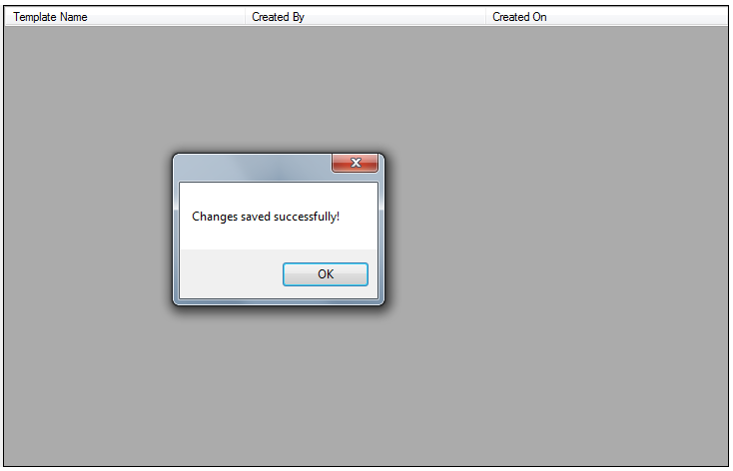

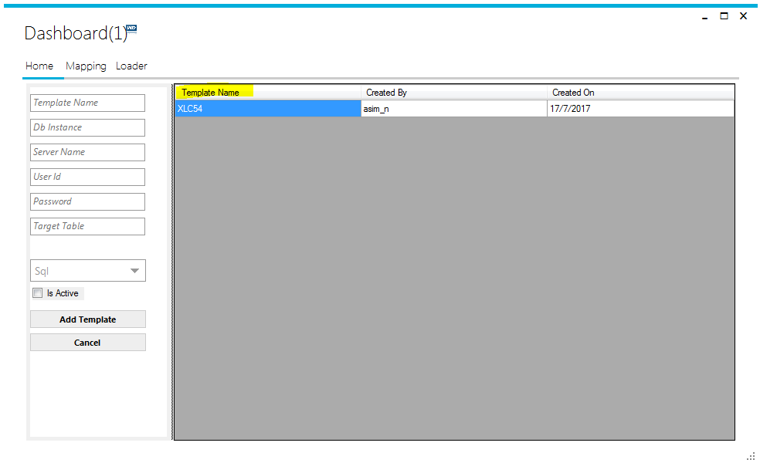

In case we need to edit/update the information of template,

* Double click on the template node in the list
* It will be populated in the form.
* After making appropriate changes, click on “Update Template” to save the changes permanently.

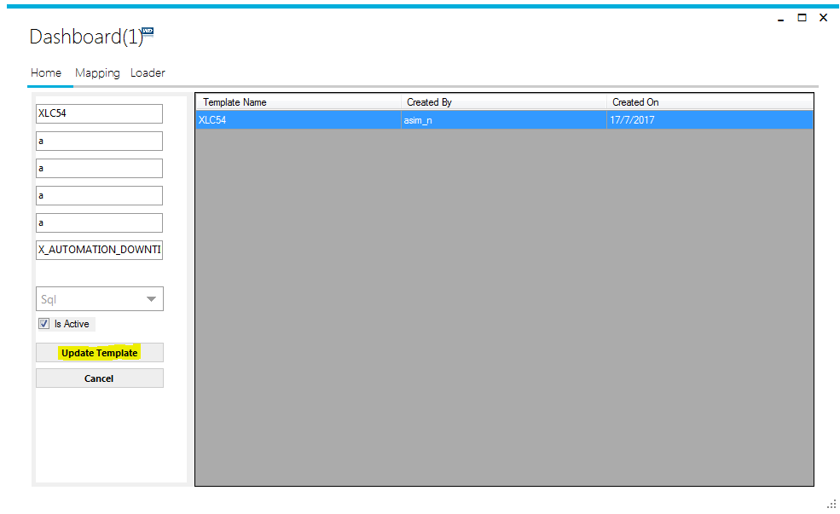

# Mapping

The second tab “Mapping” of the application is to map table columns to CSV values. By default it loads all columns of the associated table for the selected template.

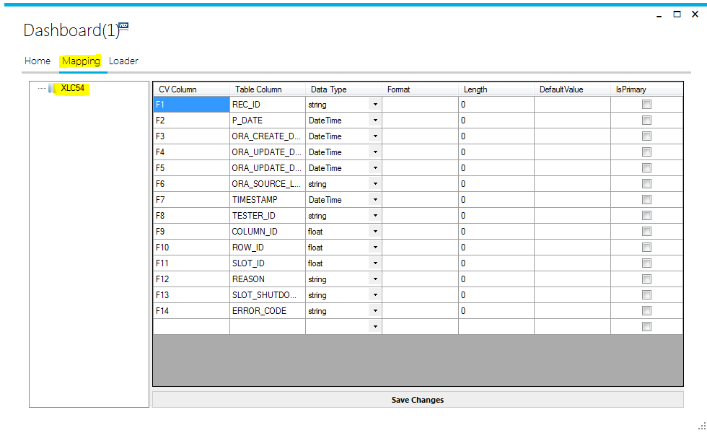

* “CV Column” is the order of values in CSV file been read by application.(Mandatory)
  + Each value must have prefix “F”
  + After “F”, the number is the location of the value in row of CSV file.
  + The number must be unique for each row in this column. Duplicate values may result error during file processing.
  + “F1” must always be associated with “REC_ID” column of database table.
  + “F1” cannot be change or deleted.
* “Table column” is the column name of associated table. That column is attached to that particular value of CSV file. (Mandatory)
* “Data Type” Column is to define the data type of the values.(Mandatory)
* “Format” column is to define the format of the value read from CSV file.

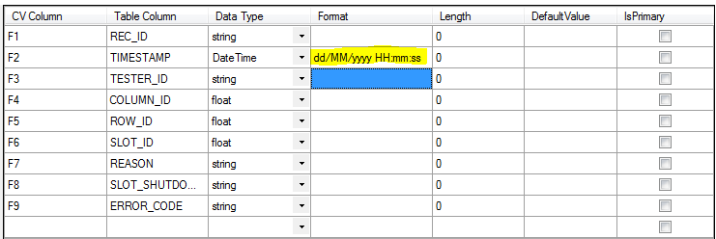

* “Length” column is to define the character length of the value to be inserted in the database. It is mandatory for columns with string datatype. The value must be exactly the same as the length of the associated column of table defined in the database.

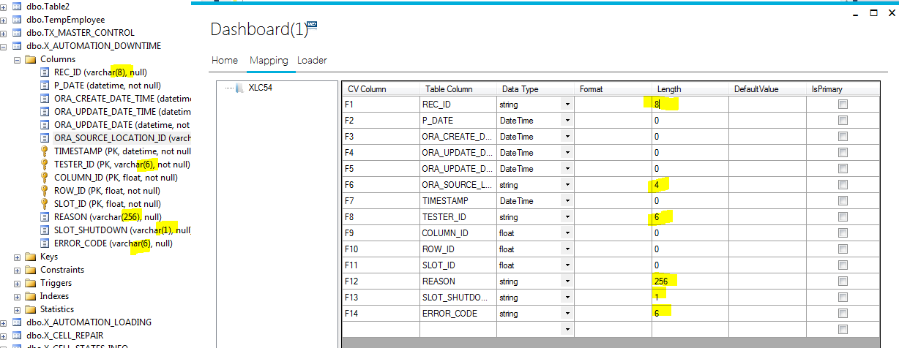

* “Default Value” column is to define the default value if any. This value will be inserted into database in case if there is no value exist in CSV file for this column.
  + In case, if there is any default value defined for that particular column in database, it will be over-written with the default value set in XLC loader application.
* “Is Primary” column is to set if the column has primary key or part of unique key index in database.
  + Mandatory if the column has primary key or unique index key.
  + “REC_ID” column will always be part of primary key.

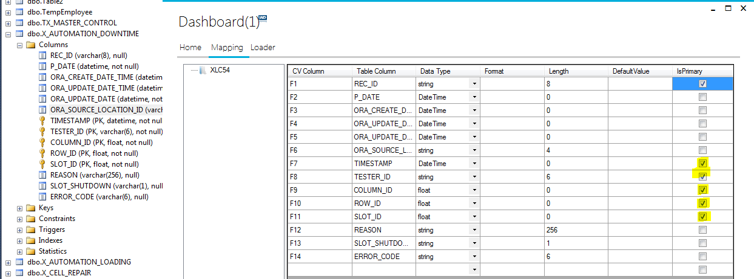

* + These values are essential to identify & update the existing row in database.

To map the database columns and CSV values follow these steps:

* To edit value in any cell of grid
  + Double click in the target cell,
  + Change the value
  + Press enter

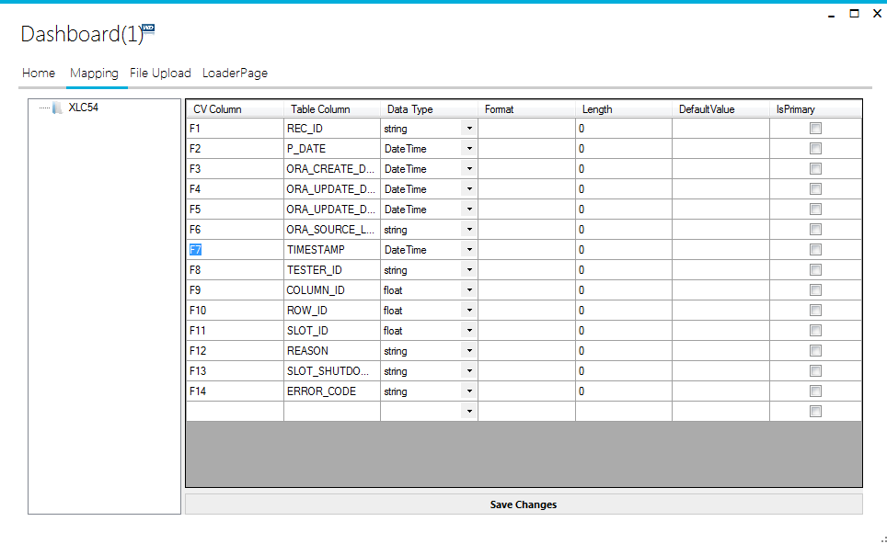

* To delete a row from grid
  + Right click on the row and select “Delete”.
  + Make sure the row must be selected before.

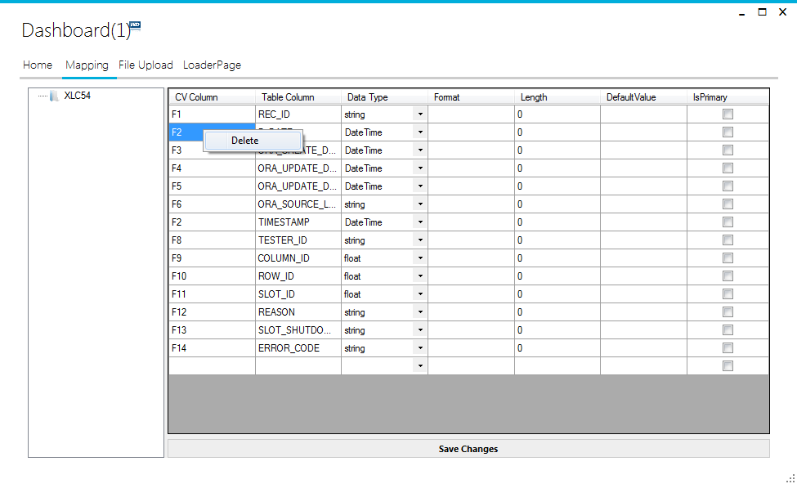

* In case if a row deleted accidently, we can create new row
  + Select the cell of empty row at bottom of the grid and type the values
  + CAUTION: the “Table Column” name must exist in the database.
* After defining all information, click on “Save Changes” button to save the changes permanently for selected template.

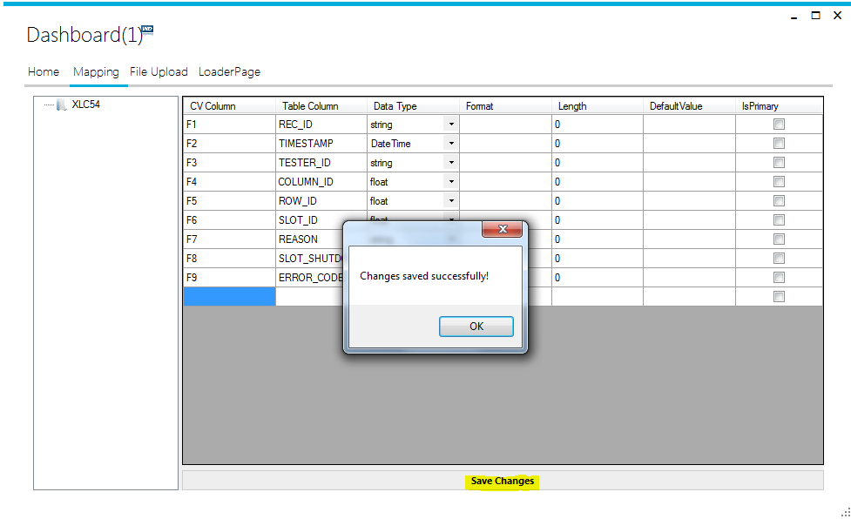

# Loader – Processing

The third tab “Loader” of the application is to process the files and see the results while application is processing files.

* Select the “Working” folder path from the folder list available at top left Hand side.
  + It is mandatory to select working folder.

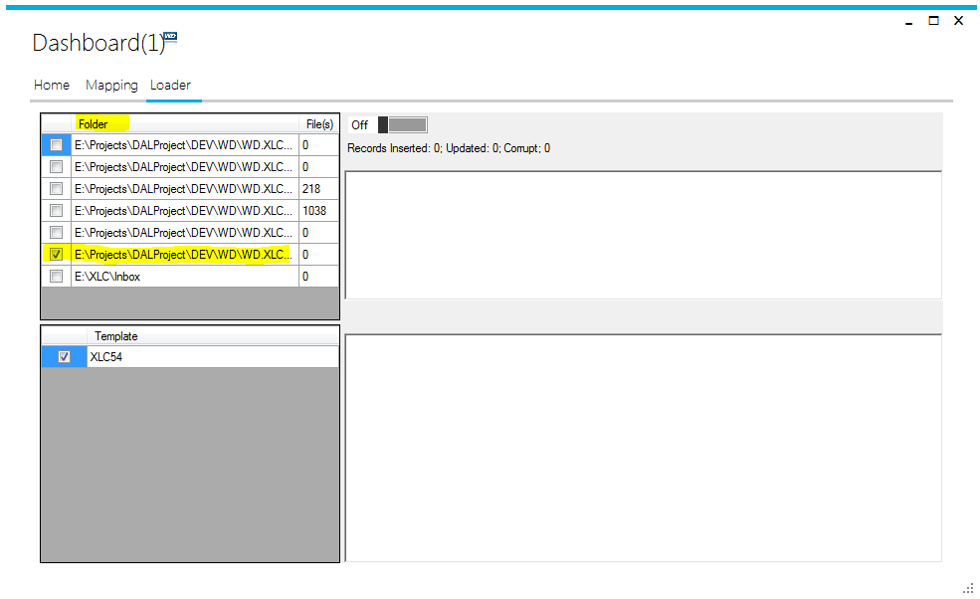

* Select the template(s) to be processed during the execution, from the template list available at bottom-left corner.
  + Must select at least one template

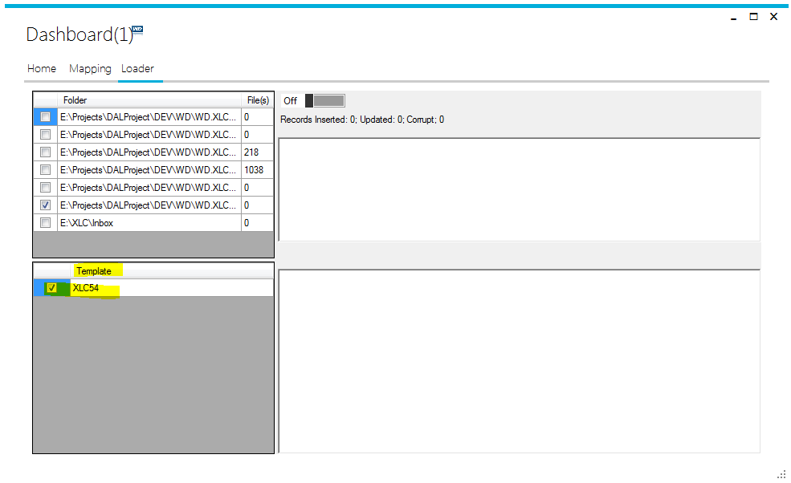

* + We can select multiple templates. As maximum as available.

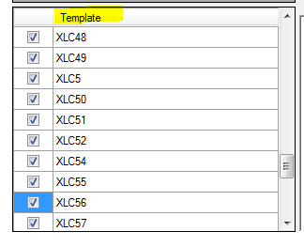

* After appropriate selections, click on the switch button to turn-on the file processing.

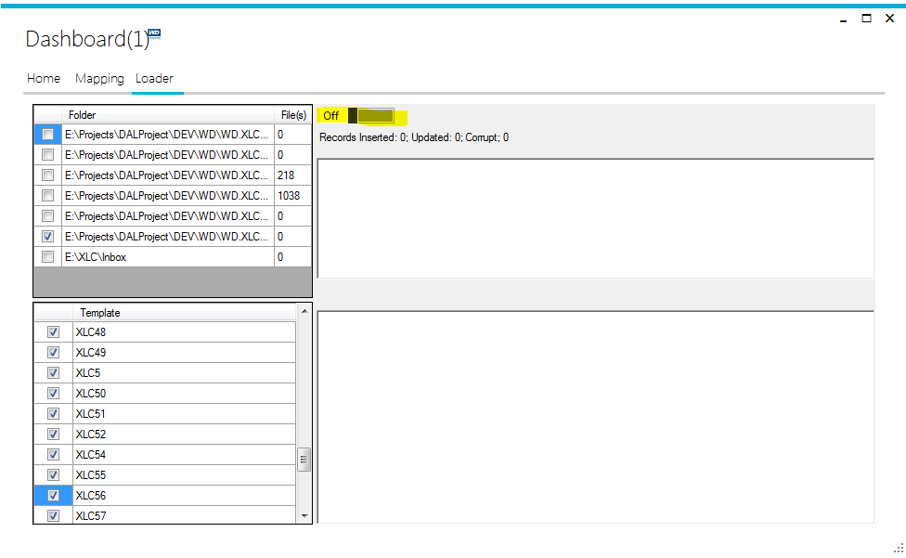

* During the processing of files, the application shows the statistical results e.g
  + Date & Time when processing starts
  + Current Date & Time
  + Time elapsed
  + Number of records inserted into the database
  + Number of records updated
  + Number of “Corrupt” records
  + Number of files processed

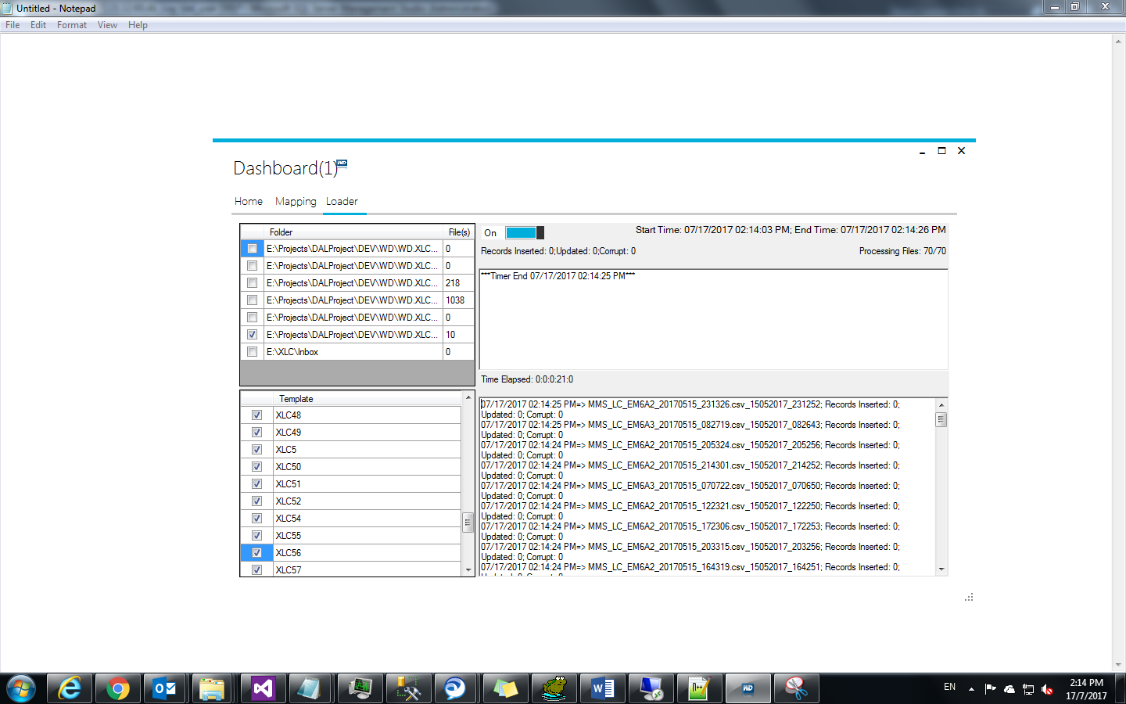

* The processing can be stop at any time by turning off the switch button.